**Fcis for travelling**

This project is made by :

1. Layla reda
2. Marihan hany
3. Marina samouil
4. Mareez Philip

**A simple description of the project :**

The idea of the project is a page on the net is booking trips to the cities of tourism within Egypt and is displayed flights available and the price of each trip and the visitor to choose the appropriate flight for him and the booking with the identification of the day of travel and the day of return and the number of individuals

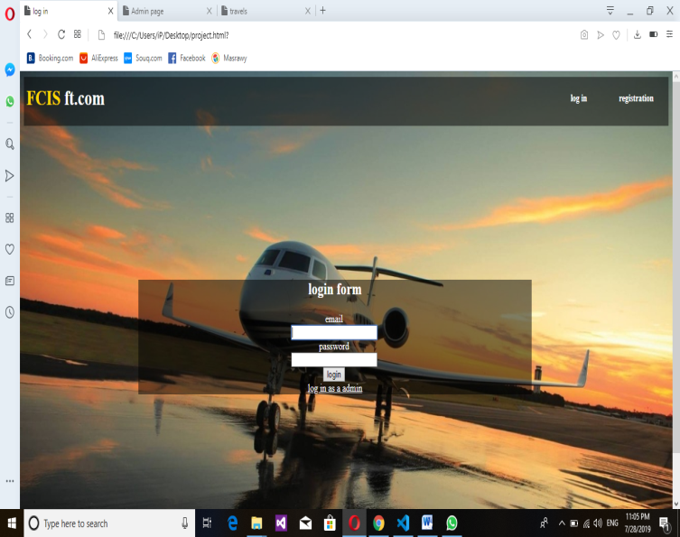

**Log in page**

This page is sure to validate the email and password to allow visitors to access the home page for available trips

Visitor must have an account

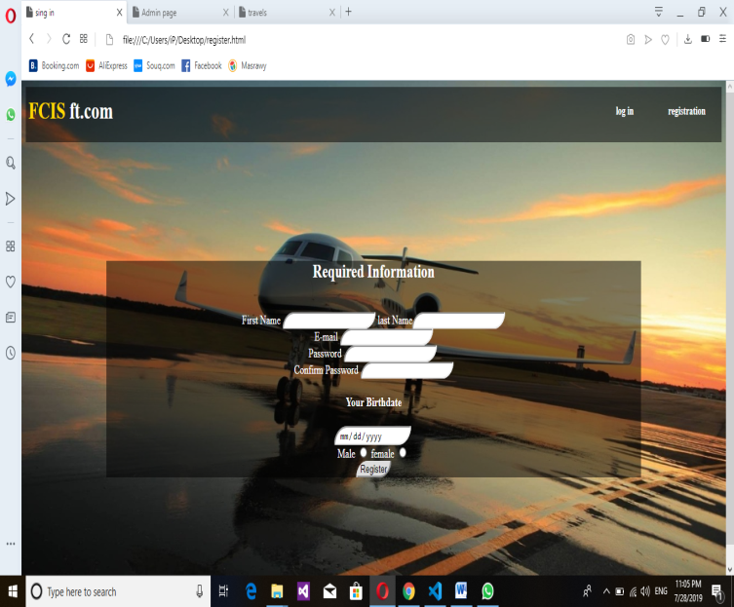

**Register page**

If you do not have an account you must register and fill out the required data to create an account on the page to make the visitor able to book the trip

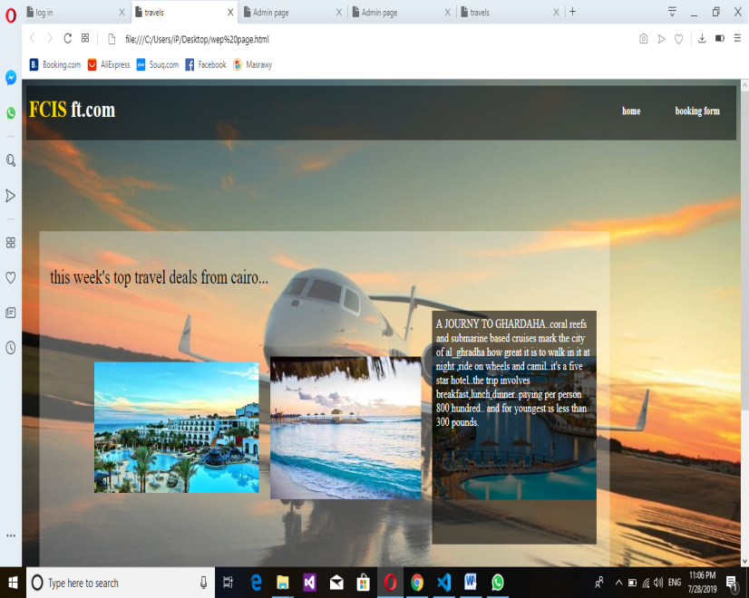

**Home page**

This page shows the available flights and each trip is displayed by the information and there is a link through which is accessed through which the page is booked by the flight

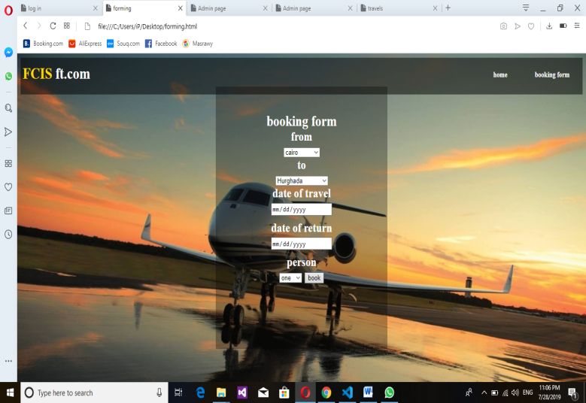**booking page**

This page enables the visitor to identify the place he wishes to reach, the number of individuals, the date of travel and departure

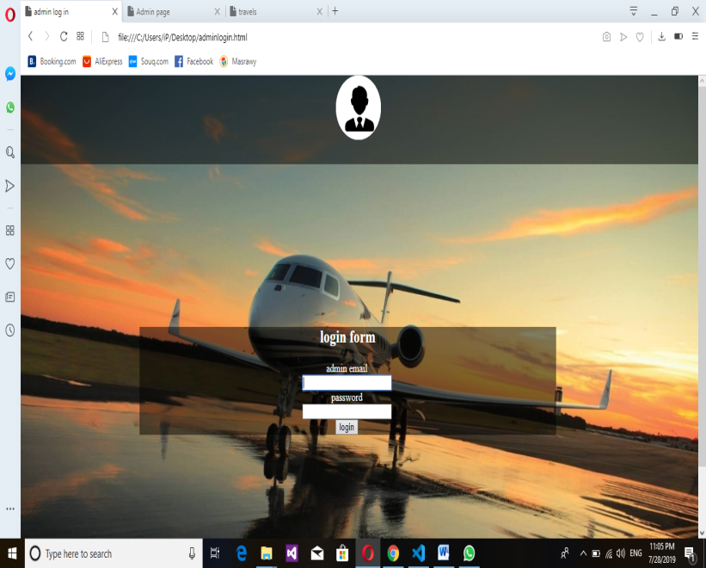**login as admin**

This page is only for the administrator of the page has its own email and password must be entered to access the page to modify the data on the pages

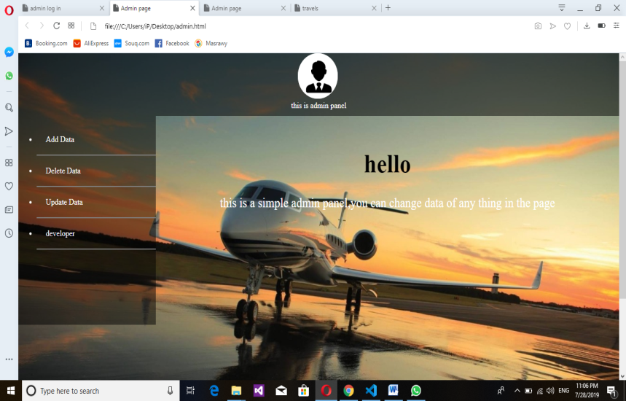**Admin page**

This page contains all the possible features that a page administrator can do, such as changing, deleting, and adding things to pages